Activitat 2.1. Enrutament senzill d'VLAN
AARON ANDAL
En aquesta pràctica, realitzareu dues configuracions per tal d’enrutar les VLANs d’un mateix switch. La primera configuració la fareu amb dos enllaços normals i la segona la fareu mitjançant un enllaç troncal.
Les dades bàsiques de les VLAN que haureu de configurar en tots dos exercicis són les següents:
- VLAN 10 - V10 - 172.16.10.0/24
- VLAN 20 - V20 - 172.16.20.0/24
Primera Configuració: Enllaços Normals
Donada la següent topologia:
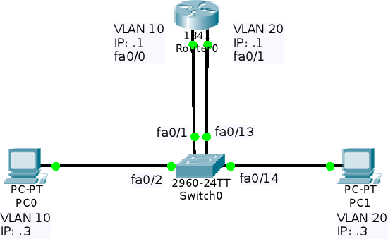
Creeu les VLANs amb les característiques indicades al capdamunt de l’enunciat. Tingueu en compte que els ports es repartiran de la següent manera:
- VLAN 10 - V10: Ports fa0/1 - fa0/12
- VLAN 20 - V20: Ports fa0/13 – fa0/24
Creació VLAN
Switch(config)#vlan 10
Switch(config-vlan)#name v10
Switch(config-vlan)#exit
Switch(config)#interface range fastEthernet 0/1-12
Switch(config-if-range)#swit
Switch(config-if-range)#switchport mode access
Switch(config-if-range)#sw
Switch(config-if-range)#switchport access vlan 10
Switch(config-if-range)#exit
Switch(config)#vlan 20
Switch(config-vlan)#name v20
Switch(config-vlan)#exit
Switch(config)#interface range fastEthernet 0/13-24
Switch(config-if-range)#switchport mode access
Switch(config-if-range)#switchport access vlan 20
Switch(config-if-range)#exit

Tanqueu tots els ports del Switch0 que no s’utilitzin.
Switch>enable
Switch#conf t
Enter configuration commands, one per line. End with CNTL/Z.
Switch(config)#interface gigabitEthernet 0/1
Switch(config-if)#shutdown
%LINK-5-CHANGED: Interface GigabitEthernet0/1, changed state to administratively down
Switch(config-if)#interface gigabitEthernet 0/2
Switch(config-if)#shutdown
%LINK-5-CHANGED: Interface GigabitEthernet0/2, changed state to administratively down
Switch(config-if)#

Configureu els PCs amb IP estàtica i connecteu-los al Switch0 (connectareu cada PC al 2n port de la VLAN corresponent).
Connecteu el Router0 al Switch0 mitjançant 2 cables Ethernet, un per cada VLAN, tal i com mostra la imatge.
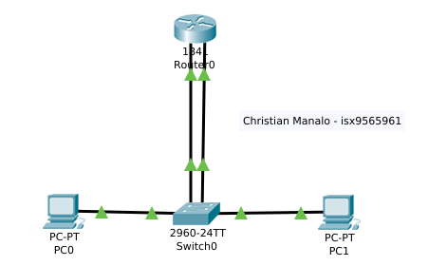

Configureu les interfı́cies del Router0.
Router>enable
Router#conf t
Enter configuration commands, one per line. End with CNTL/Z.
Router(config)#interf
Router(config)#interface fa
Router(config)#interface fastEthernet 0/0
Router(config-if)#ip address 172.16.10.1 255.255.255.0
Router(config-if)#no shutdown

Router(config-if)#
%LINK-5-CHANGED: Interface FastEthernet0/0, changed state to up

%LINEPROTO-5-UPDOWN: Line protocol on Interface FastEthernet0/0, changed state to up

Router(config-if)#exit
Router(config)#interface fastEthernet 0/1
Router(config-if)#ip address 172.16.20.1 255.255.255.0
Router(config-if)#no shutdown

Router(config-if)#
%LINK-5-CHANGED: Interface FastEthernet0/1, changed state to up

%LINEPROTO-5-UPDOWN: Line protocol on Interface FastEthernet0/1, changed state to up

Router(config-if)#

Comproveu que els PCs poden fer ping a la interfı́cie del Router0 corresponent a la seva VLAN.
Poden fer ping a la interficie del router0 corresponent a la seva VLAN pero no pot fer ping a l’altre VLAN.
PC0 – Ping router0 VLAN10
C:\>ping 172.16.10.1
Pinging 172.16.10.1 with 32 bytes of data:
Reply from 172.16.10.1: bytes=32 time=1ms TTL=255
Reply from 172.16.10.1: bytes=32 time<1ms TTL=255
Reply from 172.16.10.1: bytes=32 time=1ms TTL=255
Reply from 172.16.10.1: bytes=32 time<1ms TTL=255
Ping statistics for 172.16.10.1:

PC0 – Ping router0 VLAN20
C:\>ping 172.16.20.1
Pinging 172.16.20.1 with 32 bytes of data:
Request timed out.
Request timed out.
Request timed out.
Request timed out.
Ping statistics for 172.16.20.1:
Packets: Sent = 4, Received = 0, Lost = 4 (100% loss),
C:\>
PC1 – Ping router0 VLAN20
C:\>ping 172.16.20.1
Pinging 172.16.20.1 with 32 bytes of data:
Reply from 172.16.20.1: bytes=32 time=1ms TTL=255
Reply from 172.16.20.1: bytes=32 time<1ms TTL=255
Reply from 172.16.20.1: bytes=32 time=1ms TTL=255
Reply from 172.16.20.1: bytes=32 time<1ms TTL=255
Ping statistics for 172.16.20.1:
Packets: Sent = 4, Received = 4, Lost = 0 (0% loss),
Approximate round trip times in milli-seconds:
Minimum = 0ms, Maximum = 1ms, Average = 0ms
PC1 – Ping router0 VLAN10
C:\>ping 172.16.10.1
Pinging 172.16.10.1 with 32 bytes of data:
Request timed out.
Request timed out.
Request timed out.
Request timed out.
Ping statistics for 172.16.10.1:
Packets: Sent = 4, Received = 0, Lost = 4 (100% loss),

Comproveu que els PCs, que estan en VLANs diferents, es poden fer ping entre ells.
No tenen conexió.
PC0 – PC1
C:\>ping 172.16.20.2
Pinging 172.16.20.2 with 32 bytes of data:
Request timed out.
Request timed out.
Request timed out.
Request timed out.
Ping statistics for 172.16.20.2:
Packets: Sent = 4, Received = 0, Lost = 4 (100% loss),
Observeu la taula d’enrutament del Router0.
172.16.0.0/24 is subnetted, 2 subnets
C 172.16.10.0 is directly connected, FastEthernet0/0
C 172.16.20.0 is directly connected, FastEthernet0/1

Segona Configuració: Enllaç Troncal
Donada la següent topologia:
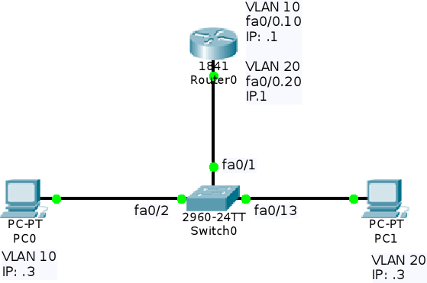
Creeu les VLANs amb les característiques indicades al capdamunt de l’enunciat. Tingueu en compte que els ports es repartiran de la següent manera:
- VLAN 10 - V10: Ports fa0/2 - fa0/12
- VLAN 20 - V20: Ports fa0/13 - fa0/24

Configureu els PCs amb IP estàtica i connecteu-los al Switch0 utilitzant els ports que indica la imatge.
PC0 – 172.16.10.2 – fa0/2
PC1 – 172.16.20.2 - fa0/13
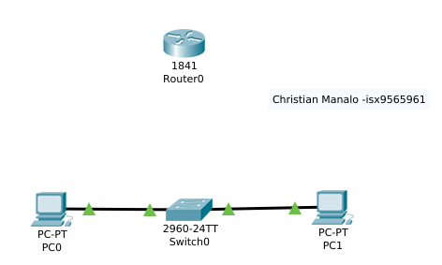

Connecteu el Router0 al Switch0 mitjançant l’enllaç troncal, tal com mostra la imatge.

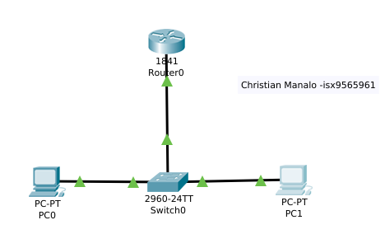

Configureu la interfície del Router0 (recordeu que heu d’utilitzar subinterfı́cies).
Router(config)#interface fastEthernet 0/0.10
Router(config-subif)#encapsulation dot1Q 10
Router(config-subif)#ip address 172.16.10.1 255.255.255.0
Router(config-subif)#exit
Router(config)#interface fastEthernet 0/0.20
Router(config-subif)#encapsulation dot1Q 10
Router(config-subif)#ip address 172.16.20.1 255.255.255.0
Router(config)#interface fastEthernet 0/0
Router(config-if)#no shutdown
Router(config-if)#
%LINK-5-CHANGED: Interface FastEthernet0/0, changed state to up
%LINEPROTO-5-UPDOWN: Line protocol on Interface FastEthernet0/0, changed state to up
%LINK-5-CHANGED: Interface FastEthernet0/0.10, changed state to up
%LINEPROTO-5-UPDOWN: Line protocol on Interface FastEthernet0/0.10, changed state to up
%LINK-5-CHANGED: Interface FastEthernet0/0.20, changed state to up
%LINEPROTO-5-UPDOWN: Line protocol on Interface FastEthernet0/0.20, changed state to up

Creació VLAN
Switch(config)#vlan 10
Switch(config-vlan)#name v10
Switch(config-vlan)#exit
Switch(config)#interface range fastEthernet 0/1-12
Switch(config-if-range)#swit
Switch(config-if-range)#switchport mode access
Switch(config-if-range)#sw
Switch(config-if-range)#switchport access vlan 10
Switch(config-if-range)#exit
Switch(config)#vlan 20
Switch(config-vlan)#name v20
Switch(config-vlan)#exit
Switch(config)#interface range fastEthernet 0/13-24
Switch(config-if-range)#switchport mode access
Switch(config-if-range)#switchport access vlan 20
Switch(config-if-range)#exit

Configureu l’enllaç troncal al port fa0/1 del Switch0 (utilitzen la VLAN 1 com a VLAN Nativa)
Switch(config)#interface fastEthernet 0/1
Switch(config-if)#switchport mode trunk
%LINEPROTO-5-UPDOWN: Line protocol on Interface FastEthernet0/1, changed state to down
%LINEPROTO-5-UPDOWN: Line protocol on Interface FastEthernet0/1, changed state to up
Switch(config-if)#switchport trunk native vlan 1
Switch(config-if)#

Comproveu que els PCs poden fer ping a la interfı́cie del Router0 corresponent a la seva VLAN.
Poden fer ping a la interficie del router0 corresponent a la seva VLAN pero no pot fer ping a l’altre VLAN.
PC0 – Ping router0 VLAN10
C:\>ping 172.16.10.1
Pinging 172.16.10.1 with 32 bytes of data:
Reply from 172.16.10.1: bytes=32 time=1ms TTL=255
Reply from 172.16.10.1: bytes=32 time<1ms TTL=255
Reply from 172.16.10.1: bytes=32 time=1ms TTL=255
Reply from 172.16.10.1: bytes=32 time<1ms TTL=255
Ping statistics for 172.16.10.1:

PC0 – Ping router0 VLAN20
C:\>ping 172.16.20.1
Pinging 172.16.20.1 with 32 bytes of data:
Request timed out.
Request timed out.
Request timed out.
Request timed out.
Ping statistics for 172.16.20.1:
Packets: Sent = 4, Received = 0, Lost = 4 (100% loss),
C:\>
PC1 – Ping router0 VLAN20
C:\>ping 172.16.20.1
Pinging 172.16.20.1 with 32 bytes of data:
Reply from 172.16.20.1: bytes=32 time=1ms TTL=255
Reply from 172.16.20.1: bytes=32 time<1ms TTL=255
Reply from 172.16.20.1: bytes=32 time=1ms TTL=255
Reply from 172.16.20.1: bytes=32 time<1ms TTL=255
Ping statistics for 172.16.20.1:
Packets: Sent = 4, Received = 4, Lost = 0 (0% loss),
Approximate round trip times in milli-seconds:
Minimum = 0ms, Maximum = 1ms, Average = 0ms
PC1 – Ping router0 VLAN10
C:\>ping 172.16.10.1
Pinging 172.16.10.1 with 32 bytes of data:
Request timed out.
Request timed out.
Request timed out.
Request timed out.
Ping statistics for 172.16.10.1:
Packets: Sent = 4, Received = 0, Lost = 4 (100% loss),

Comproveu que els PCs, que estan en VLANs diferents, es poden fer ping entre ells.
No tenen conexió.
PC0 – PC1
C:\>ping 172.16.20.2
Pinging 172.16.20.2 with 32 bytes of data:
Request timed out.
Request timed out.
Request timed out.
Request timed out.
Ping statistics for 172.16.20.2:
Packets: Sent = 4, Received = 0, Lost = 4 (100% loss),
Observeu la taula d’enrutament del Router0.
172.16.0.0/24 is subnetted, 2 subnets
C 172.16.10.0 is directly connected, FastEthernet0/0.10
C 172.16.20.0 is directly connected, FastEthernet0/0.20

Activeu i configureu l’accés per Telnet al Router0.
Router#conf t
Enter configuration commands, one per line. End with CNTL/Z.
Router(config)#line vty 0 2
Router(config-line)#password cisco
Router(config-line)#login
Router(config-line)#exit

Comproveu que, des de qualsevol dels dos PCs, podeu accedir a la configuració del Router0 a través del terminal Telnet que acabeu d’activar.
PC0
C:\>telnet 172.16.10.1
Trying 172.16.10.1 ...Open
User Access Verification
Password:
Router>

PC1
C:\>telnet 172.16.20.1
Trying 172.16.20.1 ...Open
User Access Verification
Password:
Router>

